Testing Conductivity of Materials with a BBC Micro:Bit
The program
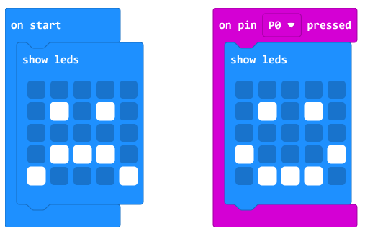
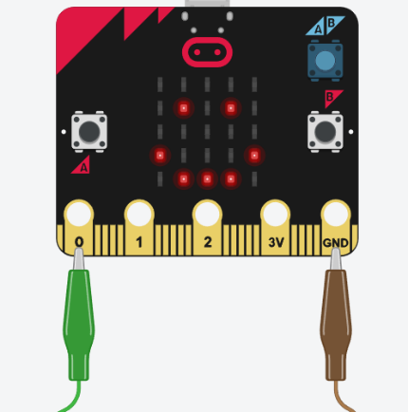
Download this to your Micro:Bit.
Setting up your Micro:Bit
Connect one of your cables to Pin 0
Connect the other cable to the GND Pin
Check your program works by touching the two loose ends together – if you get the smiley face, it works!
If not, double check the wiring and the program.

The Experiment
- Choose a material and write a prediction of whether you think the material is conductive or not.

- Connect the cables to either end of the material.

- If electricity can flow through the material, your Micro:Bit will show the smiley face.

- Fill in the results table for this material

- Reset the Micro:Bit and repeat with each material.

