Introduction to BBC Micro:Bit Programming
The Program: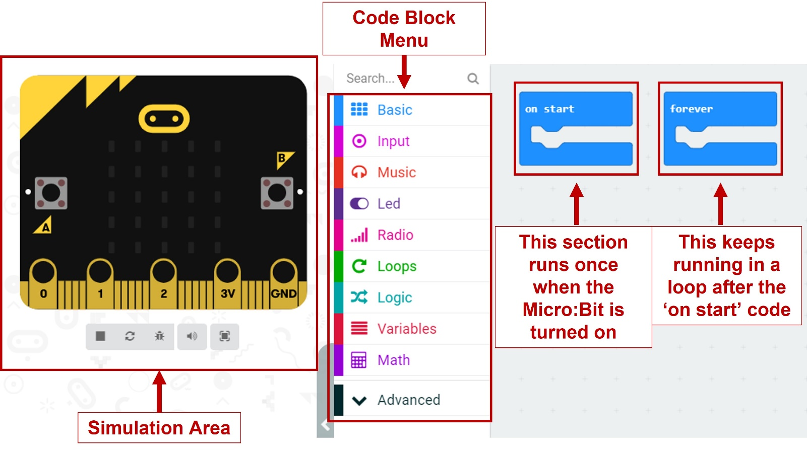
Note: You should only have one ‘on start’ and one ‘forever’ block in any program.
You can click and drag coding blocks from the menu into your program:
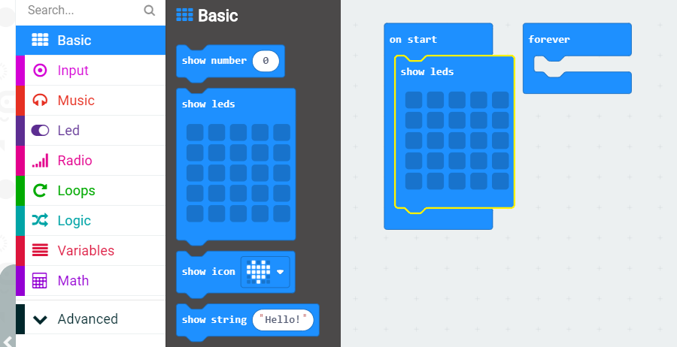

Challenge One: The Start Screen
Setting up your own start-up sequence for your Micro:Bit.
You can draw your own start-up image by clicking on the squares in the ‘show leds’ block.
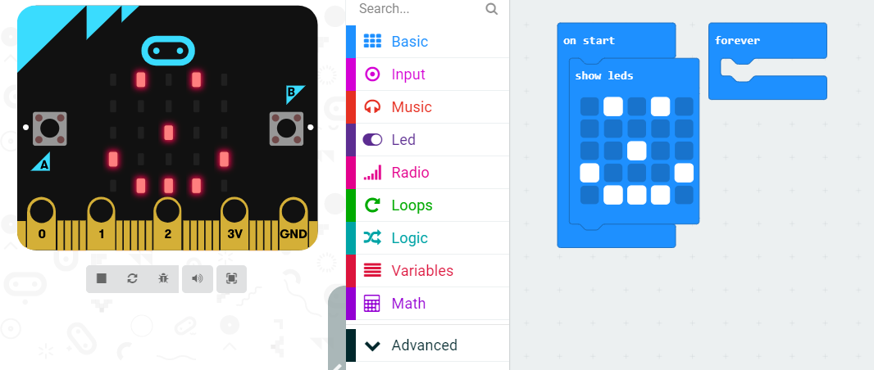

Or you can use the ‘show icon’ block to select an image.
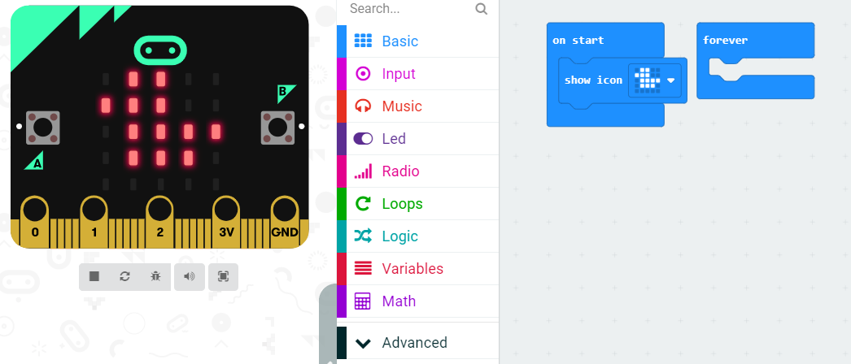

You will then need to decide how long the image stays on the screen for by adding a ‘pause’ block underneath.
The pause is measured in milliseconds (ms). There are 1000ms in one second.

You can add a message using the ‘show string’ block.
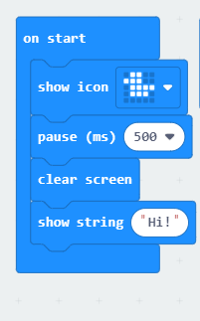
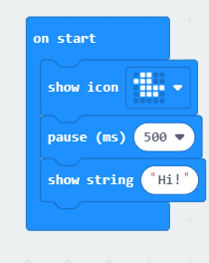
It takes time for each letter to scroll across the screen, so you want to keep any messages short.
You may want to add a ‘clear screen’ block before showing the message.
Now try having the message show before the image.

You can use the simulation controls to test your program. The cirucular arrow button will restart the program.
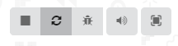
Extra: Start Screen Animation
Can you produce a short animation using two pictures and the ‘repeat block’ instead of having a single image?
For Example:
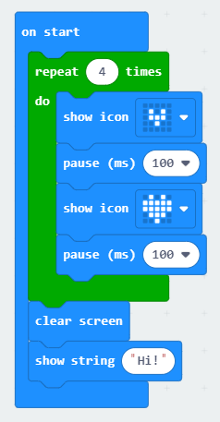

Try to copy this in your program.
Notice how this uses a green block of code from the Loop menu.
You can decide how many times it repeats in the green block by changing the number.
You can try different images but always remember to use a pause after each one or it will appear and disappear too quickly.

Challenge Two: Using Buttons
The Micro:Bit has several different inputs including two buttons.
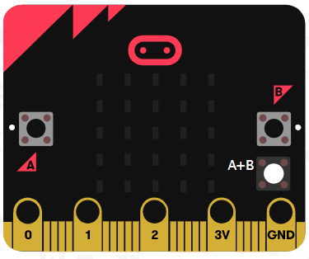

Because the simulator can only be clicked on with a mouse, we cannot press both buttons at the same time, so it has an extra white button labelled A+B to use.
Note: This only appears once you include its block in your code.

We can program the Micro:Bit to do different things depending on which button is pressed.
There are three choices of button input:
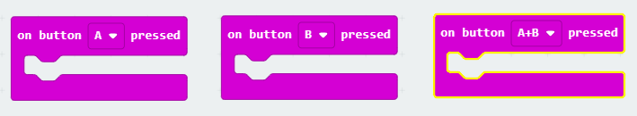
This block is found in the Input block menu.
We can now tell the Micro:Bit to show a different image for each button pressed.
For example:
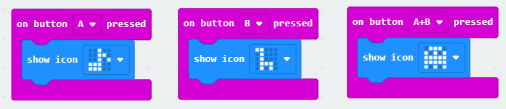
You could also include messages and/or animations for each button in the same way as we did for the start screen in Challenge One.

Extra: Other Inputs
The Micro:Bit has sensors that can tell if it’s moving, shaking, tilting, falling and bumping.
These can be added using the ‘on shake’ input block as seen here:
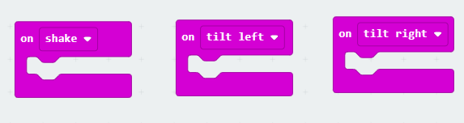
If you include these three blocks in your code, your simulator will change again. A shake button is added and the Micro:Bit will tilt when you move the mouse over it.
How will your Micro:Bit react to being shaken or tilted?

Challenge Three: Adding Sound
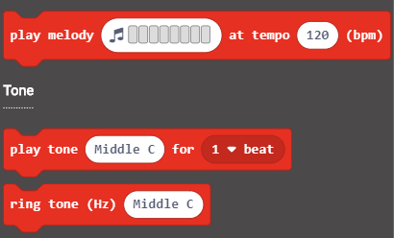
The Micro:Bit has a speaker that can play a range of different tones.

The blocks for including sound are in the Music section of the menu.
You can include melody blocks, note blocks and/or ring tone blocks

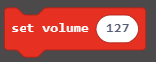
Try to add different sound effects to each of your input blocks.
Please include the ‘set volume’ block in the ‘on start’ section of your program and change the number to 50. This will allow people to hear their own Micro:Bit once downloaded without drowning out others.

Downloading to a BBC Micro:Bit
The simulator only shows the front of the Micro:Bit computer. For this stage we need to look at the back.
Battery Plug-in
Power Button
Computer Plug-in

First we will need to connect a battery pack to the Micro:Bit, then turn it on to run the test program already installed on it.
Follow the instructions on the screen to test all the inputs and sensors are working.
Now connect the Micro:Bit to the computer with the cables provided.
Once plugged in, select the … button next to the Download button:
Follow the instructions to connect your Micro:Bit
Now, press the Download button which should look like this:
You can now unplug the Micro:Bit from the computer and test your program.

