Measuring Acceleration with BBC Micro:Bit

These devices come with a built-in accelerometer. As Micro:Bits can communicate with each other using radio, we can have one (the transmitter) sending data to another (the receiver). This means we will need to write two programs, one for each Micro:Bit.
The Transmitter:
Create a new project for this program.
You only need to add 3 blocks: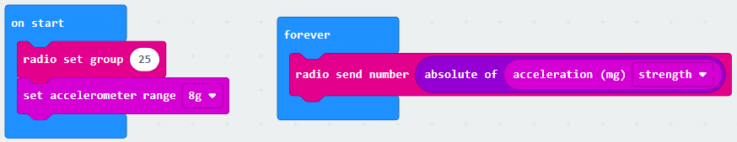
You will need to change the radio set group value to a unique one for your program. A staff member will make sure no-one has the same group number.
Also, you need to add a start screen to identify that the program is running and which Micro:Bit is your transmitter.
Download to a Micro:Bit which will then need to be connected to a battery pack.
The Receiver:
Create a new project for this program.
The basic program looks like this:
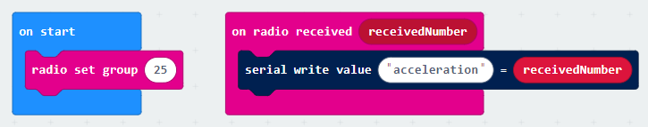
Change the radio set group to match with your transmitter.
Add a start screen to identify this is your receiver and that the program is running.
Download to a Micro:Bit which then remains connected to your computer. Do not close this program.

Testing your transmitter/receiver programs:
The transmitter should be connected to a battery pack.
The receiver needs to remain plugged into the laptop.
If all is working correctly, the program screen for the receiver should now a new button beneath the simulation:
Click on this to open up the console screen and see the live data in numerical and graph forms.
As you move the receiver around, the acceleration should show on your graph.
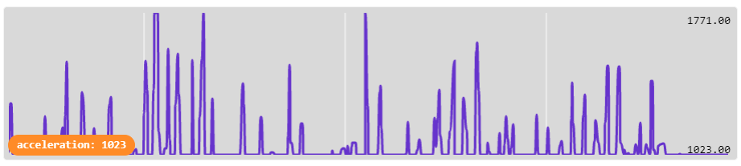

Now we are ready to experiment!

Problem shooting:
Check both your transmitter and receiver are on the same radio group number.
Make sure your radio group number is different to the other groups’.
Are both Micro:Bits turned on?
Check you have not accidentally mixed up which one is the transmitter, and which is the receiver.
Make sure you are on the program screen for the receiver.
Is the Micro:Bit receiver connected to the laptop? You should have this download button if it is:

